**Screenshots of survey questionnaire**

We present the screenshot of the original German survey along with an English translation below. We only focus on the questions analyzed for the current paper.

**Target questions**

**Employment detail**

*Straightforward version*

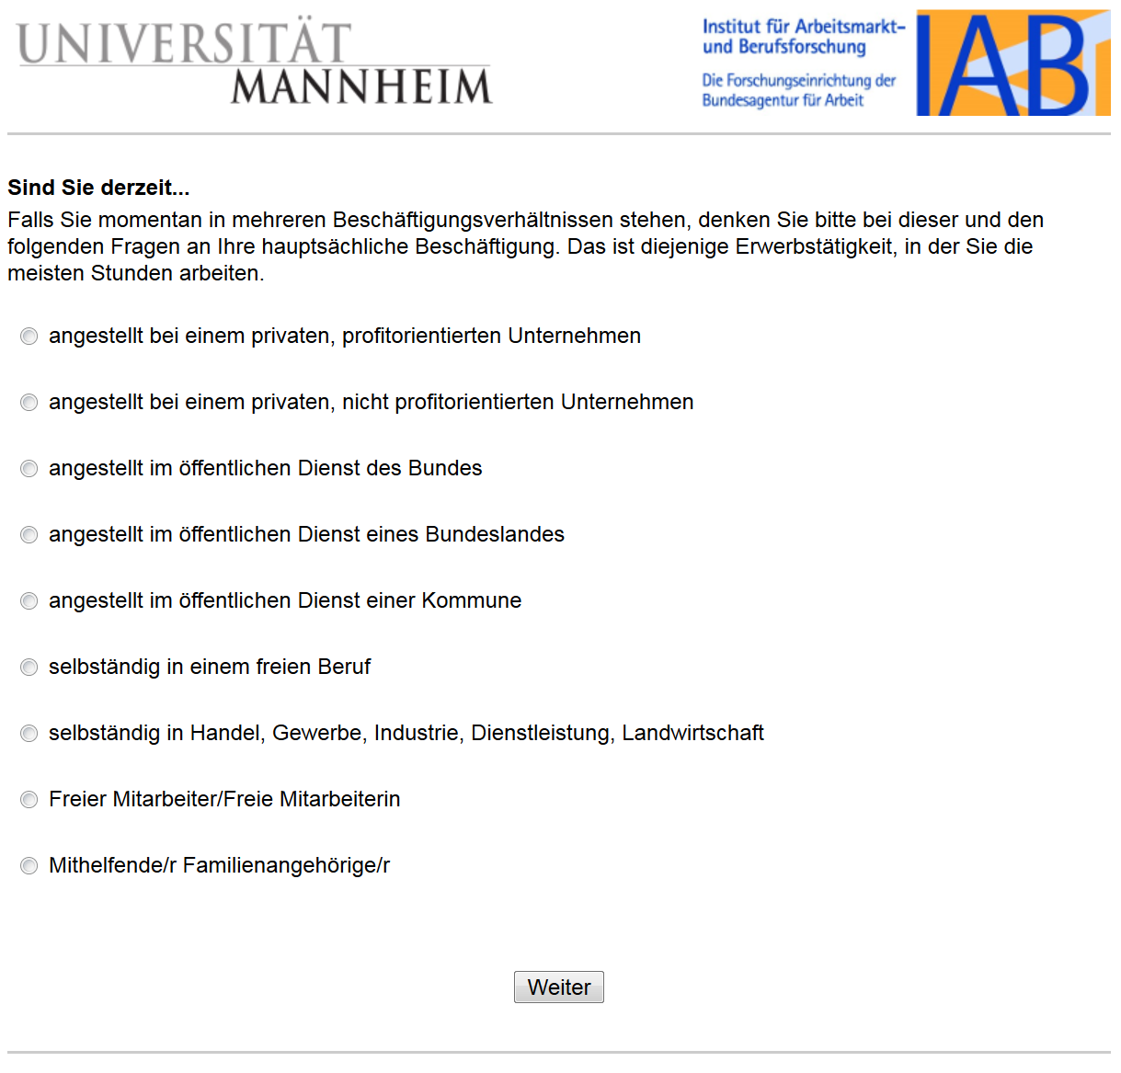

**Are you currently…**

If you are currently involved in multiple jobs, please consider your primary employment in this and the following questions. Your primary employment is the job in which you work the most hours.

Employed at a private, profit-oriented company

Employed at a private, not profit-oriented company

Employed in the civil service of the federation

Employed in the civil service of a federal state

Employed in the civil service of a municipality

Self-employed in an independent profession

Self-employed in trade, commerce, industry, service, agriculture

Freelancer

Assisting family members

**Employment detail**

*Complex version*

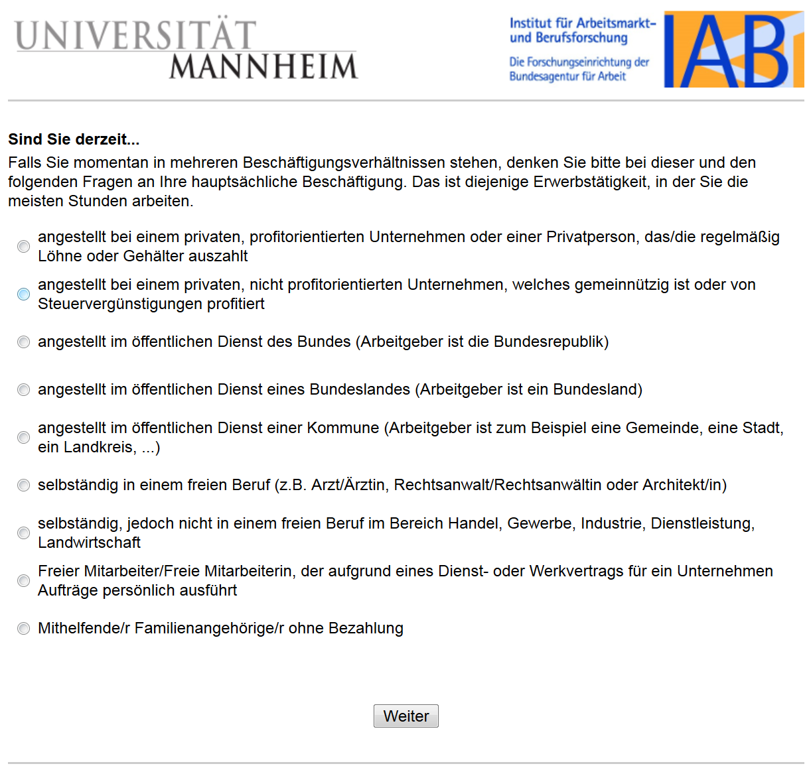

**Are you currently…**

If you are currently involved in multiple jobs, please consider your primary employment in this and the following questions. Your primary employment is the job in which you work the most hours.

Employed at a private, profit-oriented company or private individual who regularly pays wages or salaries

Employed at a private nonprofit-oriented which is charitable or benefits from tax credits

Employed in the public service of the Federal Government (the employer is the Federal Republic)

Employed in the civil service of a federal state (the employer is the federal state)

Employed in public service of a municipality (the employer is, for example, some municipality, city, district…)

Self-employed in an independent profession (for example, doctor, lawyer or architect)

Self-employed, but not in an independent profession, in the field of commerce, industry, services, agriculture

Freelancer who executes orders for companies through a service or work contract

Assisting family members with no salary

**Employee level**

*Ordered version*

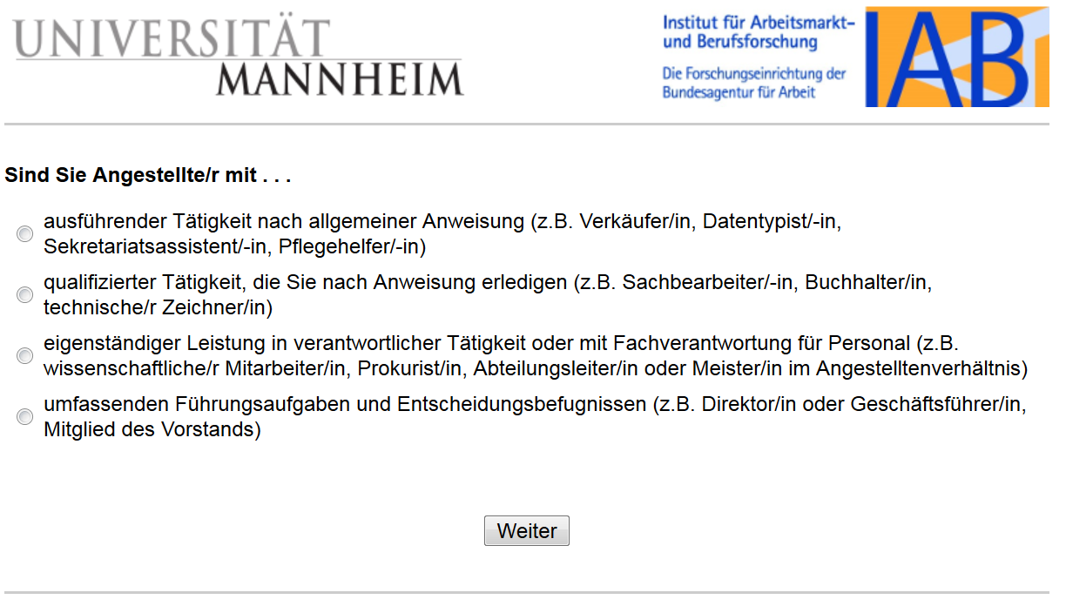

**Are you employed with….**

Executing occupation following instructions (e.g., salesperson, data typist, secretarial assistant, nursing assistant)

Qualified occupation following instructions (clerk, accountant, technical draftsman)

Independent activities in a responsible occupation or with functional responsibilities for personnel (e.g., scientific employee, authorized signatory, department manager, or master employee)

Comprehensive management tasks and decision-making powers (e.g., director or managing director, member of the executive board)

**Employee level**

*Unordered version*

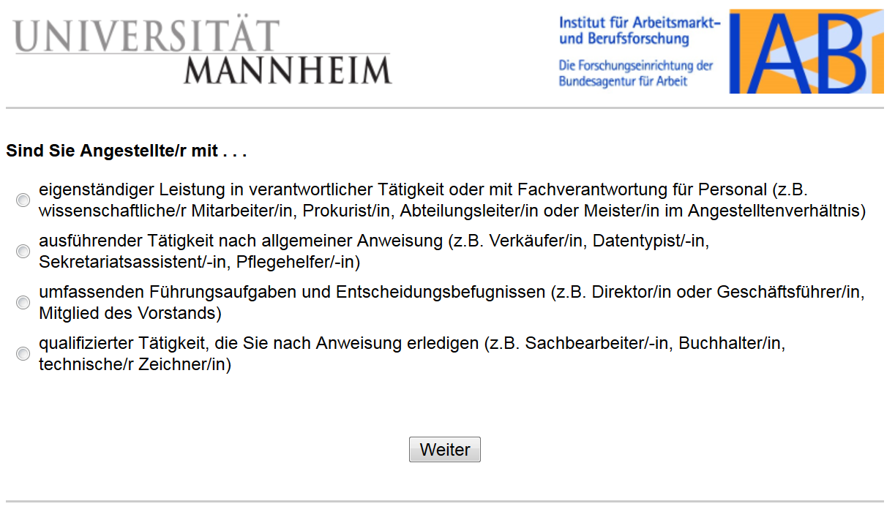

**Are you employed with….**

Independent activities in a responsible occupation or with functional responsibilities for personnel (e.g., scientific employee, authorized signatory, department manager, or master employee)

Executive occupation following instructions (e.g., salesperson, data typist, secretarial assistant, nursing assistant)

Comprehensive management tasks and decision-making powers (e.g., director or managing director, member of the executive board)

Qualified occupation following instructions (clerk, accountant, technical draftsman)

**Educational level**

*Ordered version*

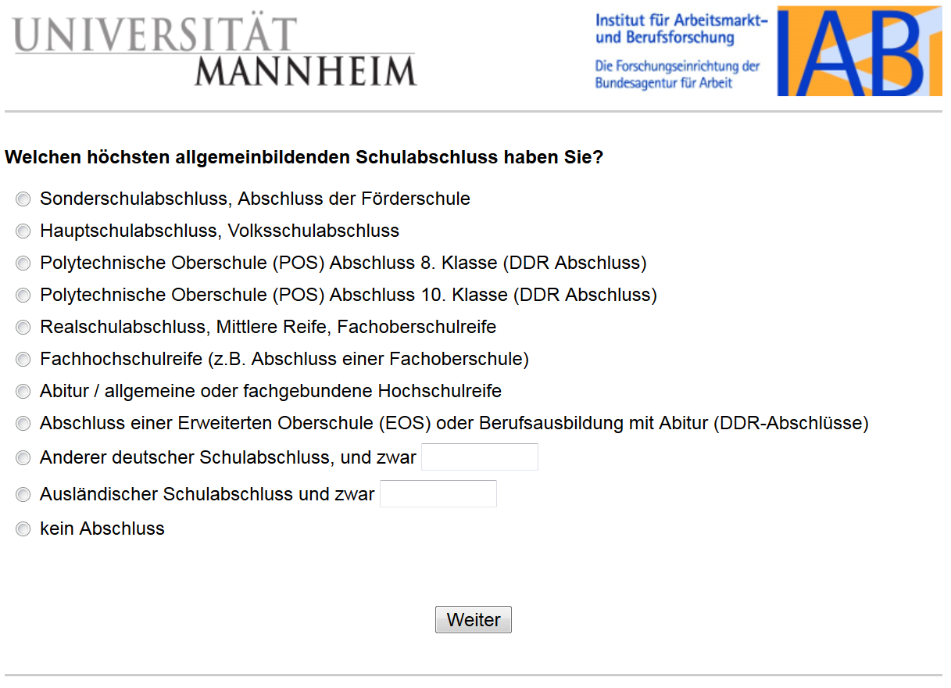

**Note: only a rough translation is possible here as the terms refer to specific certificates in the German school system:**

**Which is your highest school leaving certificate?**

Special school graduation

Lower secondary education

8th-grade graduation (DDR graduation) in Polytechnic High School (POS)

10th-grade graduation (DDR graduation) in Polytechnic High School (POS)

Higher secondary education

[University](https://www.dict.cc/englisch-deutsch/university.html) [of](https://www.dict.cc/englisch-deutsch/of.html) [applied](https://www.dict.cc/englisch-deutsch/applied.html) [sciences](https://www.dict.cc/englisch-deutsch/sciences.html) [entrance](https://www.dict.cc/englisch-deutsch/entrance.html) [qualification](https://www.dict.cc/englisch-deutsch/qualification.html)

General qualification for university entrance

Completion of Extended Secondary School (EOS) or professional education (DDR graduation)

Graduation from another German school, which is _______

Graduation from a foreign school, which is _______

No graduation

**Educational level**

*Unordered version*

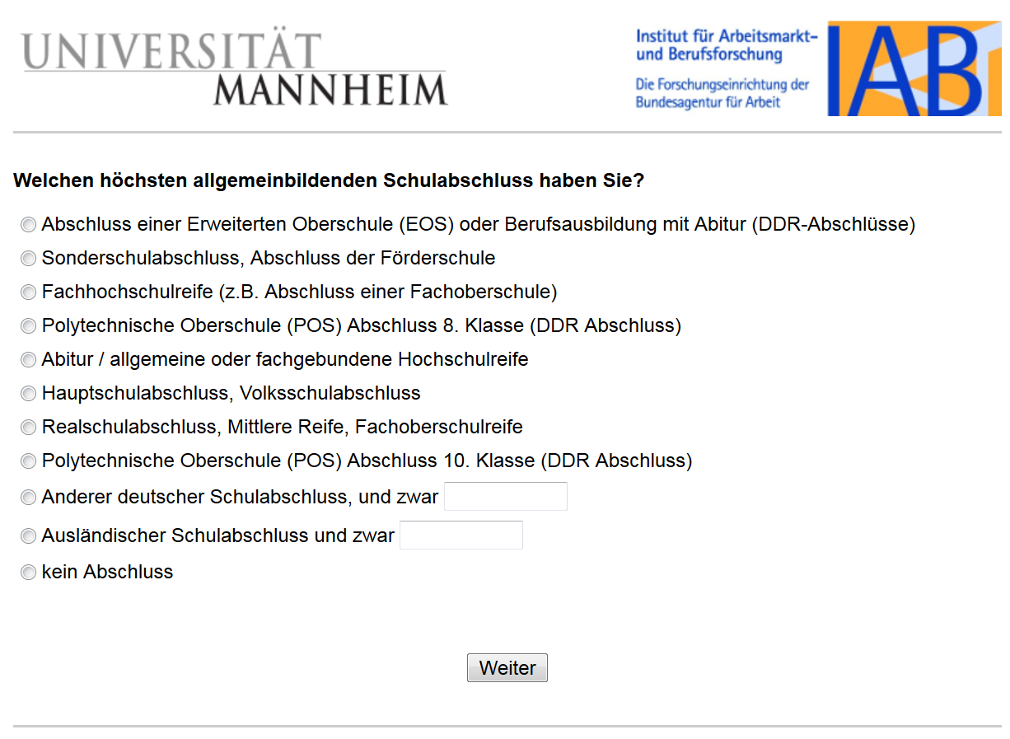

**Note: only a rough translation is possible here as the terms refer to specific certificates in the German school system:**

**Which is your highest school leaving certificate?**

Completion of Extended Secondary School (EOS) or professional education (DDR graduation)

Special school graduation

[University](https://www.dict.cc/englisch-deutsch/university.html) [of](https://www.dict.cc/englisch-deutsch/of.html) [applied](https://www.dict.cc/englisch-deutsch/applied.html) [sciences](https://www.dict.cc/englisch-deutsch/sciences.html) [entrance](https://www.dict.cc/englisch-deutsch/entrance.html) [qualification](https://www.dict.cc/englisch-deutsch/qualification.html)

8th-grade graduation (DDR graduation) in Polytechnic High School (POS)

General qualification for university entrance

Lower secondary education

Higher secondary education

10th-grade graduation (DDR graduation) in Polytechnic High School (POS)

Graduation from another German school, which is _______

Graduation from a foreign school, which is _______

No graduation

**Baseline questions**

**General economic situation**

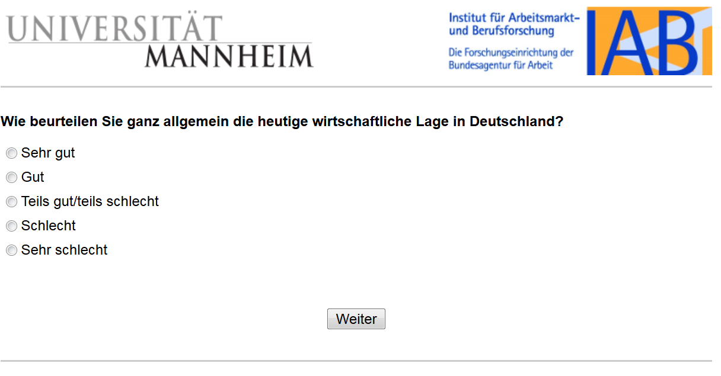

**How do you evaluate, in general, the current economic situation in Germany?**

Very good

Good

Partly good, partly bad

Bad

Very bad

**Personal economic situation**

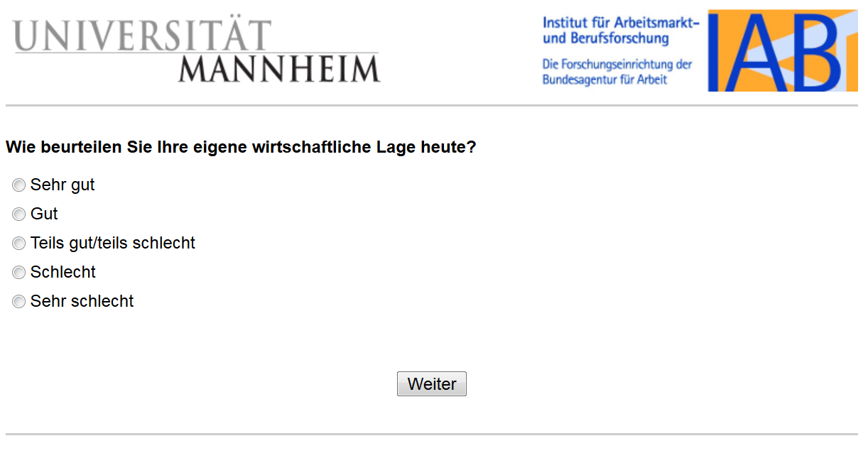

**How do you evaluate your own economic situation today?**

Very good

Good

Partly good, partly bad

Bad

Very bad

**Employment contract type**

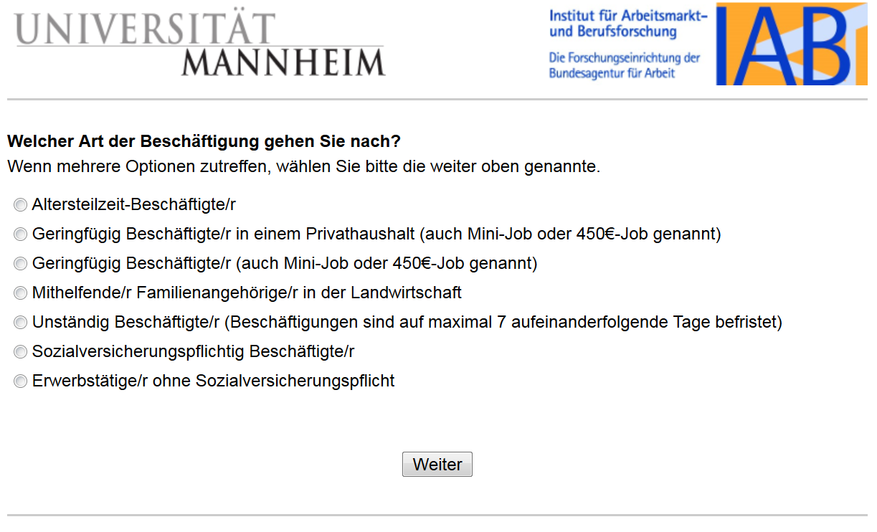

**What is your current type of employment?**

If several options apply, please choose the one mentioned further above.

Partial retirement employment

Marginal employment in a private household (also called mini-job or 450 €-job)

Marginal employment (also called mini-job or 450 €-job)

Assisting as a family member in agriculture

Non-regularly employed (employments are limited to a maximum of 7 consecutive days)

Employed subject to social insurance contribution

Employed not subject to social insurance contribution

**Employment type**

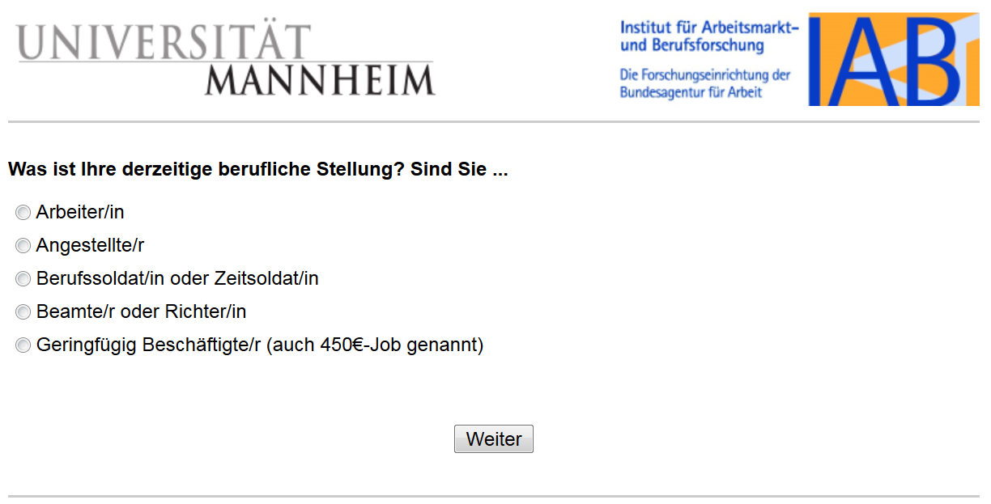

**What is your current occupation? Are you …?**

Worker

Employee

Professional soldier

Official or judge

Marginally employed (also called 450€-job)

**Marginal employment (mini-job)**

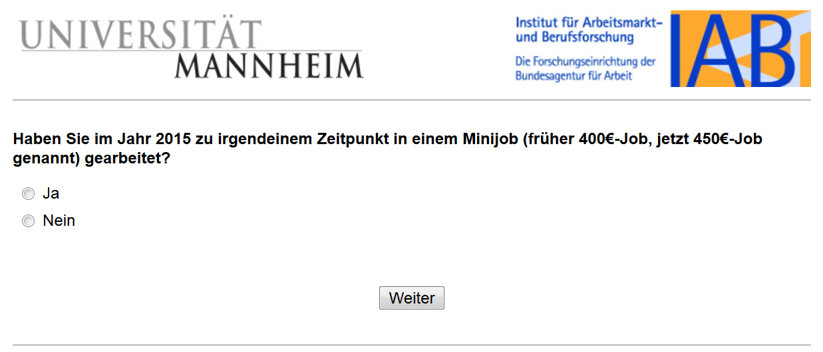

**Have you been working in a mini-job at any time in 2015 (formerly a 400€-job, now called a 450€-job)?**

Yes

No

**Unemployment insurance**

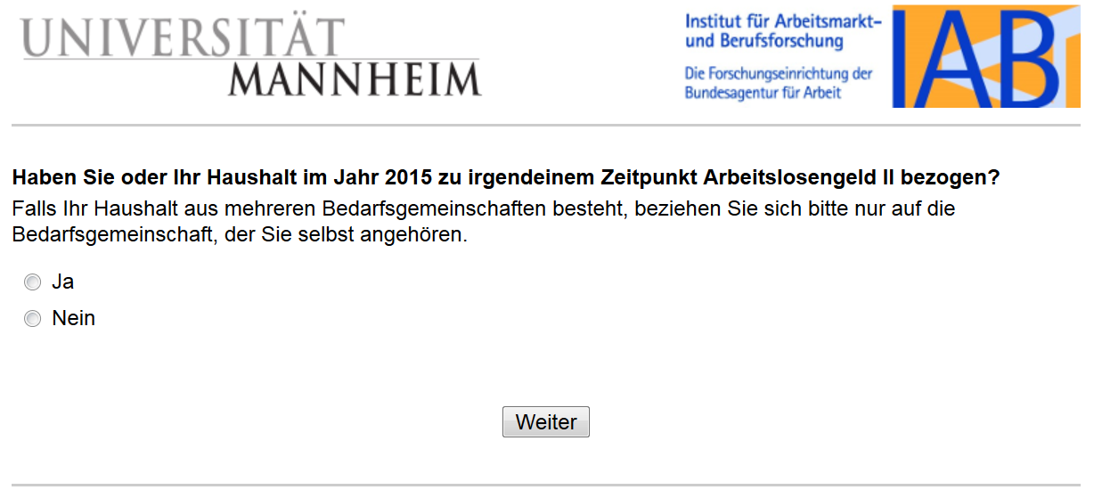

**Did you or your household receive unemployment benefits (type II) at any time in 2015?**

If your household consists of several groups (German term: Bedarfsgemeinschaften), please only refer to the community to which you belong.

Yes

No

**Salary inflation**

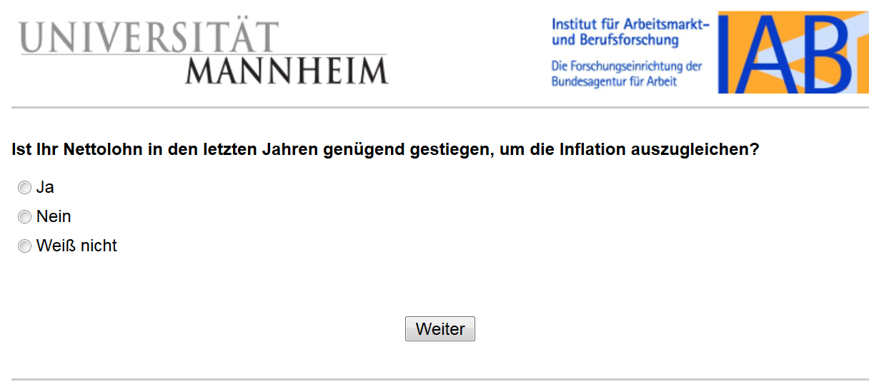

**Has your net salary increased sufficiently in the last years to make up for inflation?**

Yes

No

I don’t know

**Employee representation satisfaction**

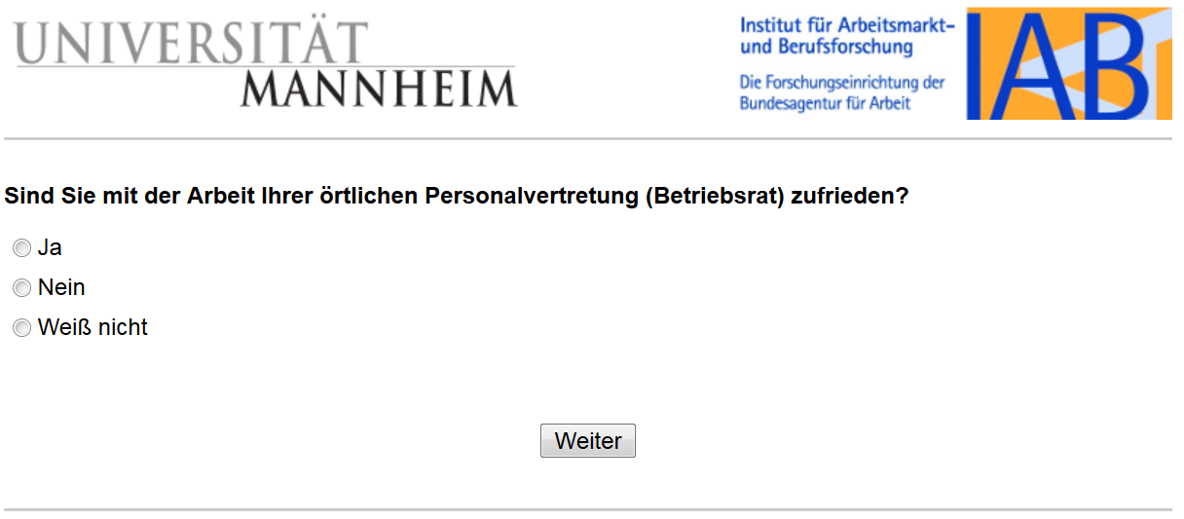

**Are you satisfied with the work of your local employee representation (workers’ council)?**

Yes

No

I don’t know